Harding, Kevin, Dr (from Linked In)

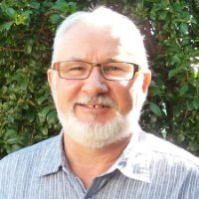

Woodlawn College 1969 – 1974. B.Sc.(Forestry), Wood Science and Wood Products/Pulp and Paper Technology ANU 1975 – 1978. PhD, Forestry Genetics North Carolina State University 1991 – 1995.

Research Assistant Australian National University, Dept of Forestry 1979 – 1982. Wood Quality Imrovement Scientist Queensland Dept of Forestry 1982 – 1989. Principal Scientist DEEDI, Forestry Science 1982 – 2011. Short-term advisor on wood quality research AIDAB Australia-China Technical Co-operation Forestry Project 1987 –1989 Dongmen Forest Farm, Guangxi, PRC. Graduate student NCSU Forestry TIP Co-op 1991 – 1995. Partner Scientist ACIAR project (China and Vietnam) 2005 – 2009. Project Partner Forest Enterprises Australia Ltd 2005 – 2010. Project 2.5 leader CRC Forestry 2006 – 2010. Science Leader (Acting) Forestry Science, QLD Dept Agriculture, Fisheries and Forestry Queensland Government DAFF 2011 –2012 Townsville, Queensland and EcoSciences Precinct, Brisbane, Qld. Science Leader (acting) DAFF, Qld 2012 Townsville / Dutton Park. Adjunct Research Professor University of the Sunshine Coast 2012 – .Sippy Downs, Queensland. Consultant/Small Private Forest Grower Harding Forestry 2012 – .

